THE LOKUM BOAZKERE STORY
This is the story of a winemaker and a viticulturalist who, in 2005, found themselves in a delightful open-air restaurant on the shores of the Bosphorus in Istanbul. We were there to work but we needed to eat….so we found a table and called for the wine list.
That was probably our first mistake….sure, there was the odd Chardonnay on the list but most of the varieties were unrecognisable to us. We took a punt and tried the 2001 Doluca “Kav” Öküzgözü-Boğazkere blend (disclaimer…we were in Turkey at the request of Doluca to review their production).
We also ordered a Turkish version of the mixed grill to accompany the wine. Both the food and the wine were outstanding but while I cannot remember the exact details of what was on the plate, I can vividly recall what was in the glass.
I had never tasted a wine like this before…at once medium-bodied yet rich and full of flavour. Yes, there were tannins but they melted on to the palate especially in company with the food. The aromas were new to me, full of spice and exotic fruit scents.
These two Turkish indigenous varieties set us on the path you can follow today. After a year working with Doluca, we decided that we should bring some of these vines back to Australia since we had a hunch they would grow well in our hot dry inland summers. But which one?
Öküzgözü (which translates to “ox’s eye”), a large-berried, aromatic grape with great potential but somewhat difficult to grow well in our view. I have always felt it has some style similarities with a good Shiraz…relatively soft tannins, smooth and round and with great popular appeal.
Or Boğazkere (which translates roughly to “throat-burner”), a wickedly tannic variety with exotic dried fruit and jube-like flavours. It’s like Nebbiolo on steroids, we thought. It’s also a real winemaking challenge.
So in the end, we went for Boğazkere as the first step. It’s a fascinating grape, unlike anything I have ever seen before.
Here’s a vineyard in the Diyarbakir region of Turkey, the traditional home of Boğazkere:
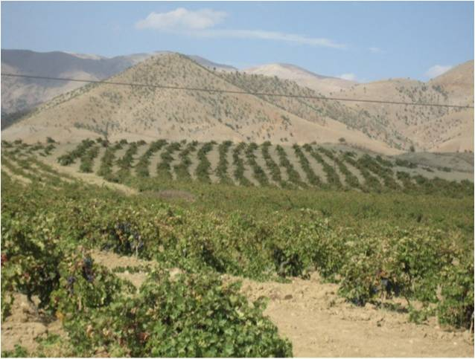
Diyarbakir is hot and dry (very hot and very dry) so we settled on Central Victoria (near Dookie) to plant our vineyard.
So far, so good. We are still learning how to best approach this unique variety and I must say that we haven’t been disappointed yet. If you want to try something completely different, give it a shot.

